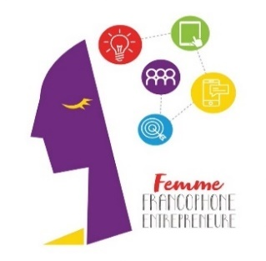

**Press Release**

# Launching of the “Femme Francophone Entrepreneure” 2024 Competition:

# A 30,000-Euro grant and a 6-month accompaniment to 4 winners

***Beirut, April 29, 2024* – For the 13th year in a row, AUF Middle East, Berytech and L’Orient-Le Jour are giving francophone women entrepreneurs the opportunity to develop their business through the “Femme Francophone Entrepreneure” competition. Three Lebanese projects, and one from the Middle East but not from Lebanon, will share a 30,000-Euro funding and benefit from training and coaching sessions for six months at Berytech.**

As was the case in 2023, the current edition of the FFE will be marked by the internationalization of the competition. The call for applications is now open to the 17 AUF member countries in the Middle East other than Lebanon (Saudi Arabia, Cyprus, Djibouti, Egypt, the United Arab Emirates, Ethiopia, Iraq, Iran, Jordan, Palestine, Pakistan, Qatar, Somalia, Sudan, Syria, Turkey and Yemen).

AUF is giving francophone women entrepreneurs (SMEs/ start-ups) residing in Lebanon and to projects led by francophone women residing in the abovementioned countries the chance to apply for the competition in order to receive support and funding for their projects:

* 22,000 Euros to the 3 Lebanese winners (1st prize: 9,000 Euros, 2nd prize: 7,000 Euros, 3rd prize: 6,000 Euros)
* 8,000 Euros to the winner from the Middle East but not from Lebanon.

The file should be submitted in French and the presentations to the jury will also be made in French.

**To apply:**  [**https://berytech.jotform.com/231352696112048**](https://berytech.jotform.com/231352696112048)

**Deadline:** May 31, 2024

It is worth recalling that during the 2023 edition, out of the hundred files received following the call for applications, 33 were preselected prior to selecting 6 finalist candidates: 4 in the start-up category and 2 in the SME category. The educational digital platform developed by two female doctors, gynecologist/obstetrician Gaël Abou Ghannam and sex therapist Sandrine Atallah, won the 12th edition jury over. The second prize was awarded to Gaïo Cosmetics, a company established in 2020 by Gaëlle el-Chaer, a Doctor of Pharmacy. The third prize went to Vietrail and to its founder Christelle Gemayel, who offers her customers a new take on stained-glass window such as souvenirs and customized art objects designed in a spirit of innovation and attachment to the Lebanese cultural and artistic heritage. On the other hand, Heba Refaat El Hattab (Egypt) won the regional prize (6,000 Euros) for her project Alex-stars, which aims at creating job opportunities in simultaneous interpretation in Alexandria.

**Press contact**  Joëlle Riachi – [joelle.riachi@auf.org](mailto:joelle.riachi@auf.org) +961 3 780 928